* ANN can not recognize the images that are larger in size
* For example, handwritten digit classification can be done using ANN as the images of hand written digits are very small in size
* But in case of Koala, the image size is very big i.e., the image size is 1920 * 1080 * 3 (RGB representation)
* Therefore first layer of neurons = 1920 * 1080 * 3 ~ 6 million
* And Hidden layer neurons = Let's say you keep it ~ 4 million
* Weights between input and hidden layer = 6 mil * 4 mil = 24 million
* And this is too much of computation for normal machines

# Disadvantages of Artificial Neural Network?

* Too much computation
* Treats local pixels same as pixels far apart
* Sensitive to location of an object in an image

# How do humans recognize images so easily?

* First when we look at a Koala's image, we look at the small features like eyes, nose, ears. And we aggregate these results
* In our brain, there are different sets of neurons working around different features like eyes, nose and ears, and they are fired when they detect these small features.
* And these neurons are connected to another set of neurons which will aggregate these results.It will say if in the image you are seeing Koala’s eyes, nose and ears, then there is Koala’s head in the image
* Similarly, if there is Koala’s hands and legs are in the image, the 1st hidden layer of neurons will tell that there is Koala’s body in the image
* And again there will another layer of neuron that aggregates that if Koala’s head and body is in the image, then the image is of Koala’s images

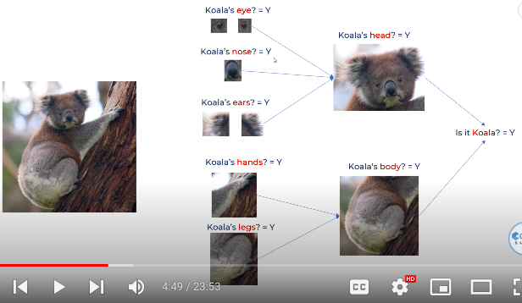

* Same thing works in case of hand written images as well
* 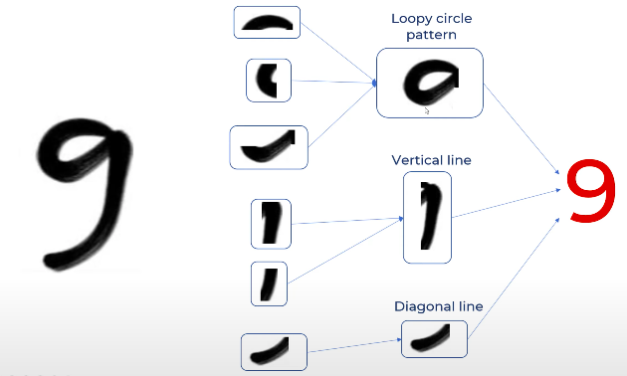

# How can we make computers recognize these tiny features?

* We use the concept of filter
* In case of nine, we have 3 filters. Those are: loopy circle, vertical line and diagonal line.
* So we take original image and perform convolution/filter operation
* 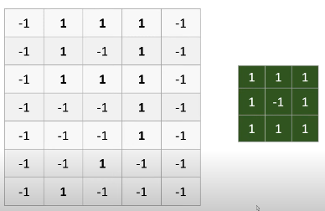
* The green color matrix in the above image is the filter/convolution for the loopy circle in the number 9
* We take the loopy circle filter matrix and multiply it with the main matrix (image) by taking 3 by 3 matrix n the main matrix and then aggregate the value as shown in the below image
* 